COMP3322 Modern Technologies on World Wide Web
Assignment 2 (9%)
[Learning Outcomes 2, 3]
Due by: ?
Overview
In this assignment, you are going to develop a simple web-based news feed application using technologies learned in class for creating dynamic web pages, i.e., PHP, Javascript/jQuery, AJAX, HTML and CSS. The new feed application implements a few simplified functionalities, including displaying one page of news, switching among different pages of news, displaying the details of one news and users’ comments, login to add comments for one news and log out to stop commenting.

Prepare database tables
Prepare the following database tables in your database in the server sophia.cs.hku.hk
1. Create a database table users, which stores information of registered user in the news feed application. Each user entry in the table must contain the following attributes:
- userID – The unique ID of the entry. Assume that the userID is an integer starting from 0.
- name – The registered name of the user (less than or equal to 20 characters).
- password – The registered password of the user (less than or equal to 20 characters).
- icon – The path (which can be absolute or relative path) to the file of the icon used to represent that user (e.g., a photo of the user). The path should be less than or equal to 255 characters.

For your reference, the following SQL statement creates the users table.
CREATE TABLE users (
userID int(11) NOT NULL,
name varchar(20) NOT NULL,
password varchar(20) NOT NULL,
icon varchar(255) NOT NULL,
PRIMARY KEY (userID)
)
The following SQL statement inserts a user entry into the users table.
INSERT INTO users( userID, name, password, icon)
VALUES (
'1',
'Harry',
'12345',
'images/1.jpg'
);

Insert at least three user entries into the users table, for testing your program.

2. Create a database table news. Each news entry in the table must contain the following attributes:
- newsID – The unique ID for each news. Assume that the newsID is an integer starting from 0.
- newsTitle – The title of the news (less than or equal to 100 characters).
- content – The textual content of the news.
- time – The time when the news was created (less than or equal to 30 characters).
For your reference, the following SQL statement creates the news table.
CREATE TABLE news (
newsID int(11) NOT NULL,
newsTitle varchar(100) NOT NULL,
content longtext NOT NULL,
time varchar(30) NOT NULL,
PRIMARY KEY (newsID)
)

The following SQL statement inserts a news entry into the news table.
INSERT INTO news( newsID , newsTitle, content, time)
VALUES (
'1',
'Toni Kroos: Real Madrid midfielder signs new contract',
'Germany midfielder Toni Kroos has extended his Real Madrid contract until 2022.
Spanish newspaper AS claims Kroos' new deal will earn him £346,000 a week.',
'Oct 10 2016'
);

Please prepare a sufficient number (larger than 10) of news in the news table.

3. Create a database table comments. Each comment entry in the table must contain the following attributes:
- commentID – The unique ID for each comment. Assume that the commentID is an integer starting from 0.
- newsID – The newsID identifying which news this comment is posted on.
- userID – The userID identifying who creates this comment.
- content – The textual content of the comment.
- time – The time when the comment was posted (less than or equal to 30 characters).
For your reference, the following SQL statement creates the comments table.
CREATE TABLE comments (
commentID int(11) NOT NULL,
newsID int(11) NOT NULL,
userID int(11) NOT NULL,
content longtext NOT NULL,
time varchar(30) NOT NULL,
PRIMARY KEY (commentID)
)

You don’t need to manually add comment entry into the comments table. The comment entries are dynamically created when users browse the new feed web page.

Task 1 (25 marks) Implement the overview page (index.html and handleDisplayOverview.php)
Create index.html and handleDisplayOverview.php file collectively displays an overview of the news as shown in fig. 1.
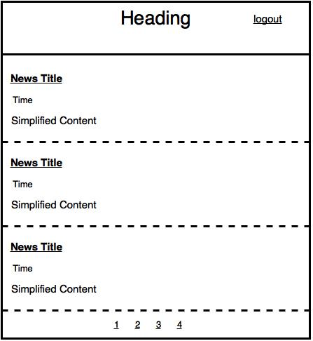
Fig.1 The overview page.
1. Create index.html file. The index.html file contains 3 divisions, which are <div id=”top”>, <div id=”middle”> and <div id=”bottom”> .

2. The news overviews are dynamically loaded using JS and PHP. When index.html is loaded for the first time, or when the user clicks a page index, the loadOverview() function retrieves the overview of 3 news and the total number of new entries from handleDisplayOverview.php. The loadOverview() function should generate an HTTP GET method with an parameter “startingNewsID” to handleDisplayOverview.php.

3. handleDisplayOverview.php uses the “startingNewsID” parameter to retrieve 3 news from the news table (Hint: To retrieve the first 3 entries from news table, you can use “select * from news limit 0, 3”). Then it calculates how many entries in the news table (Hint: you can use “select count(*) from news” to get the number of entries in the news table ).

The handleDisplayOverview.php function puts retrieved information in a JSON string. If the “userID” cookie is set for the user, handleDisplayOverview.php appends “loginStatus”:1 to the JSON string. If “userID” cookie is not set for the user, handleDisplayOverview.php appends “loginStatus”:0 to the JSONG string.

4. On the client side, loadOverview() function fills index.html in the following ways.

Create a heading (<h2>) and a button (<button>) in <div id=”top”> element. The button should display login if “loginStatus” is set to 1, or display logout if “loginStatus” is set to 0.

Create 3 news overviews in <div id=”middle”> as shown in fig. .1 Each news overview should contain a news title (h3), time (h4) and the simplified content (h3). The simplified content contains at most 15 characters of the content field of a news entry, followed by “……” symbol.

Generate page indexes in <div id=”bottom”>, according to the total number of news entries in news table. (Hint: You can store the newsID of the first news that is going to be shown after clicking a page index to a special attribute of the page index element).

5. After clicking a page index, loadOverview() should highlight the page index. If index.html is loaded for the first time, loadOverview() highlights page index 1.

Task 2 (25 marks) Implement the news display page (handleDisplayNews.php)
After a user clicks the News Title in fig. 1, the user sees fig. 2. Fig. 2 shows the details of the news that the user selects, as well as the comments that are previously posted by other users. If the user has not logged in before, he sees left side of fig. 2. If the user has logged in, the user sees right side of fig. 2 and he can add his own comment to the news.

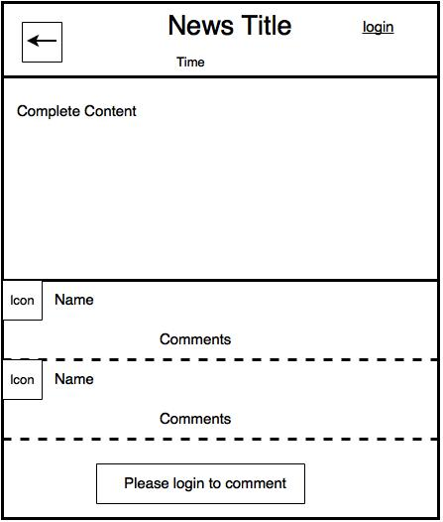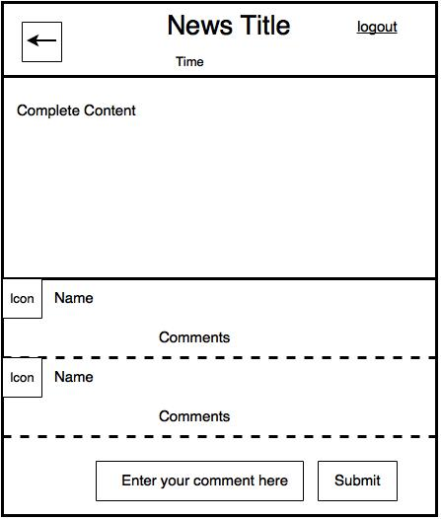
Fig.2 The display news page.

1. In fig. 1, when the user clicks the News Title, the click event will be handled by displayNews() function. The displayNews() functions send an HTTP GET request with parameter “newsID”, whose value equals to the newsID of the news that the user would like to display. The HTTP GET request is sent to handleNewsDisplay.php.

2. handleNewsDisplay.php retrieves the corresponding news entry from the news table using the “newsID” parameter as the key.

Then it retrieves all the comments from the comments table using the “newsID” parameter as the key as well. For each comment, it retrieves the user entry that posts the comment from the users table using “userID” as the key.

The handleNewsDisplay.php should store the news entry, the comments associated with this news and the users who post the comments in a JSON string.

Finally, it checks whether the user has logged in before by checking whether the “user” cookie has been set. If the “name” cookie is set, handleNewsDisplay.php appends the JSON string with “loginStatus”:”1”. If the “name” cookie is not set, handleNewsDisplay.php appends the JSON string with “loginStatus”:”0”.

The handleNewsDisplay.php then responds the client with the JSON string.

3. On the client side, the displayNews() function adds the news title (<h2>) and time (h<4>) to the middle of <div id=”top”> element. Depending on the value of the “loginStatus”, displayNews() function adds a login/logout button to the right side of <div id=”top”> element. Finally, displayNews() function adds a go back button on the right side of <div id=”top”> element.

4. The go back button has its onclick event handler bond to “goBack()” function. When the go back button is clicked, the goBack() function should generate an HTTP GET request to handleDisplayOverview.php. The goBack() function should correctly handle the responses sent from handleDisplayOverview.php to direct the user back to the page index containing the news that is being displayed now. The page index should also be highlighted.

5. The displayNews() function displays the complete content (<h3>) of the news in <div id=”middle”> element.

6. The displayNews() function should append all the comments in <div id=”bottom”> as shown in fig. 2.

7. If “loginStatus” is set to 0, the user has not logged in. The displayNews() function should append a “Please login to comment” button in <div id=”bottom”> as shown in the left side of fig. 2.

8. If “loginStatus” is set to 1, the displayNews() function should append an input box, “Enter your comment here” and a submit button.

Task 3 (20 marks) Implement posting comment (handlePostComment.php)
1. In right side of fig. 2, The submit button has its onclick event handler bond to “postComment()” function. The postComment() function generates an HTTP GET method to “handlePostComment.php” file.

2. handlePostComment.php updates the comments table with the new comment posted from the user. (Hint: the userID could be retrived from the cookie. The new commentID could be set to “select count(*) from comments”).

3. Then handlePostComment.php returns a JSON string containing all the new comments that is not displayed on user’s web page

4. The postComent() function appends the new comments after the last comment on the web page.

Task 4 (20 marks) Implement login/logout (handleLogin.php and handleLogout.php)
1. All the logout buttons have their onclick event bond to logout() function. All login buttons and “Please login to comment buttons” have their onclick event bond to login() function.

2. The login() function generates an HTTP request to handleLogin.php, which sets a cookie “userID” for the user.

3. The logout() function generates an HTTP requests to handleLogout.php, which resets the “userID” cookie for the use.

4. Both login() function and logout() function should call JS functions mentioned in previous tasks to correctly render the webpage after successfully login/logout.

Other marking criteria:
- (5 marks) Style your login, logout and chatroom HTML pages nicely using CSS rules in a style.css
2. (5 marks) Good programming style (avoid redundant code, easy to understand and maintain). You are encouraged to provide a readme.txt file to let us know more about your program.

Testing:
You should test carefully test all the functionalities mentioned in this handout. We will check your assignment submission in a similar fashion when marking.

Submission:
You should submit the following files:
(1)index.html
(2)handleDisplayOverview.php
(3)handleDisplayNews.php
(4)handlePostComment.php
(5)handleLogin.php
(6)handleLogout.php
(8)style.css
(9) any additional file(s), in case you separate your code into other files
(10) readme.txt

Please compress all the files in a .zip file and submit it on Moodle:
- Login Moodle.
- Find “Assignments” in the left column and click “Assignment 3”.
- Click “Add submission”, browse your .zip file and save it. Done.
- You will receive an automatic confirmation email, if the submission was successful.
- You can “Edit submission” to your already submitted file, but ONLY before the deadline.

